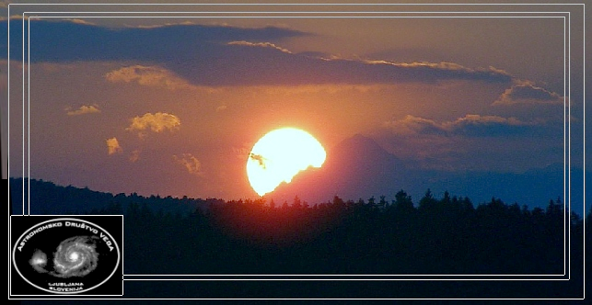

Sunset behind the highest Slovenian mountain Triglav (altitude 2864 m) on 21 June 2010. If we observe the sunset from Sentvid - Ljubljana (60 km far from Triglav) at midsummer, the Sun sets exactly behind Triglav. It is very beautiful scene and event, it is the beginning of the summer. Šentvid is a natural Stonehenge and in some ways the Sun setting behind Triglav can be seen as an artificial solar eclipse.
The Slovenian scientist Jožef Stefan (1835–1893) determined the temperature of the Sun's surface. Stefan obtained a value of 5700 K (the modern value is 5778 K). This was the first reasonable value for the temperature of the Sun. Stefan's law of emissive power
(also known as the Stefan-Boltzmann law j = σ*T⁴) was deduced by Jožef Stefan in 1879.
Dear Mrs. xxxxxxxxxxxxxxxxxxxx
Thank you so much for your visit. Vega Astronomical Society & AKG Šentvid, Slovenia, on 7 th October 2014.

Zahod Sonca za Triglavom – posneli šentviški astronomi 21. junija 2010. Sonce, gledano iz Šentvida, zahaja ob poletnem solsticiju točno za Triglavom. Aljažev stolp so skovali in 7. avgusta 1895 ponesli na slovensko goro prav kovači iz Šentvida.

Doc. dr. xxxxxxx v zahvalo za predavanje in v spomin na druženje s Šentviškimi astronomi,
AD Vega Ljubljana – 3. marec 2114

